DSA GROUP 9 WEEK ONE LABS

Q1.

#include <iostream>

using namespace std;

int main() {

//lower case is underflow

signed int y = -3147483648 ;

//upper case is overflow

signed int Y = 3147483648 ;

unsigned int z = -5;

unsigned int Z = 5000000000;

signed char x = -135;

signed char X = 135;

unsigned char u = -4;

unsigned char U = 270;

signed short s = -34000;

signed short S = 34300;

unsigned short w = -60;

unsigned short W = 67000;

return 0;

}

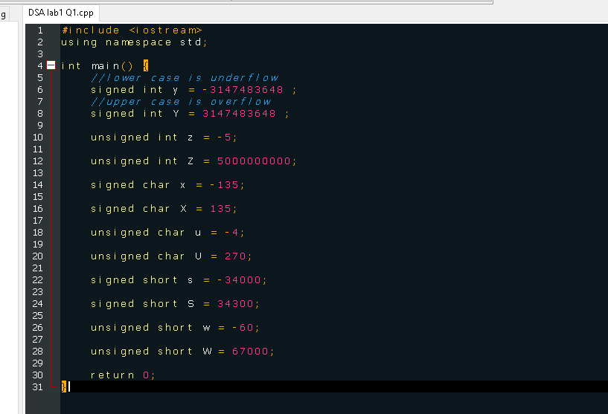

The errors we encountered when we tried running the code were that there was no output and the console displayed several error messages especially on lines 12, 14, 20 and 22 where the values are overflowing meaning the values we put exceeded the memory limit for that specific data type.

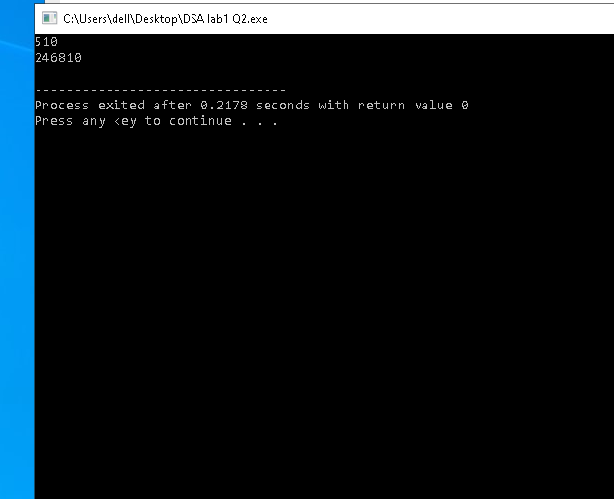Q2

Above is the output of the code at the end of the slides.

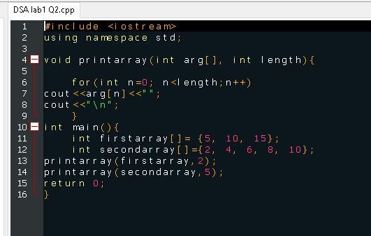

The numbers that were initialized in the 2 arrays have been printed in the output and have been printed according to the print array function where for first array 2 values have been printed instead of 3 as in the array and for the second array all five values have been printed . This is because the length in the function printarray has been specified in the main function.